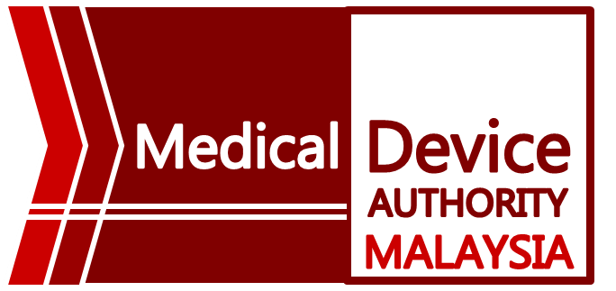
INVITATION TO PARTICIPATE IN MDA-CAB WORKSHOP IN 2026

Greetings from the Authority. Medical Device Authority (MDA) is pleased to announce an MDA-CAB workshop scheduled for the year 2026. This workshop is designed to enhance the skills and knowledge of personnel associated with Conformity Assessment Bodies (CABs) within the medical device sector.

1. MDA-CAB Workshop 2026
Date: 9 to 10 September 2026 (Wednesday and Thursday)
Registration opens: 11 May 2026
Venue: Putrajaya International Convention Centre (PICC)
*Required attendees: Registered CABs & Personnel and Medical Device Associations only

This program is tailored to benefit both existing and new CAB personnel, providing them with essential skills and knowledge to navigate the ever-evolving landscape of medical device regulations. We believe that your participation will contribute to the overall enhancement of the industry's compliance standards.

**All details are subject to any changes.

